Skip to main content

Main navigation
GE Research
- Sectors

  - Aerospace
  - Power & Energy
  - Healthcare
  - Advanced Manufacturing
  - Transportation
  - Defense & Security
  - Custom Solutions
- Technologies

  - Additive Manufacturing
  - Artificial Intelligence
  - Biology & Applied Physics
  - Controls & Optimization
  - Digital Technologies
  - Edge Computing
  - Electric Power
  - Electronics & Sensing
  - Materials
  - Mechanics & Design
  - Robotics & Autonomous Systems
  - Software & Analytics
  - Thermosciences
- Offerings

  - Commercial Services
  - Digital Solutions
  - Intellectual Property
- Clients

  - GE Business
  - Government Agencies
  - Strategic Partners
- GE Research Engine

  - Projects
  - Our People
  - Publications
  - Patents
  - R&D Facilities
  - History of Innovation
- Careers
- Contact
GE Research

- Sectors
- Technologies
- Offerings
- Clients
- GE Research Engine
- Careers
- Contact

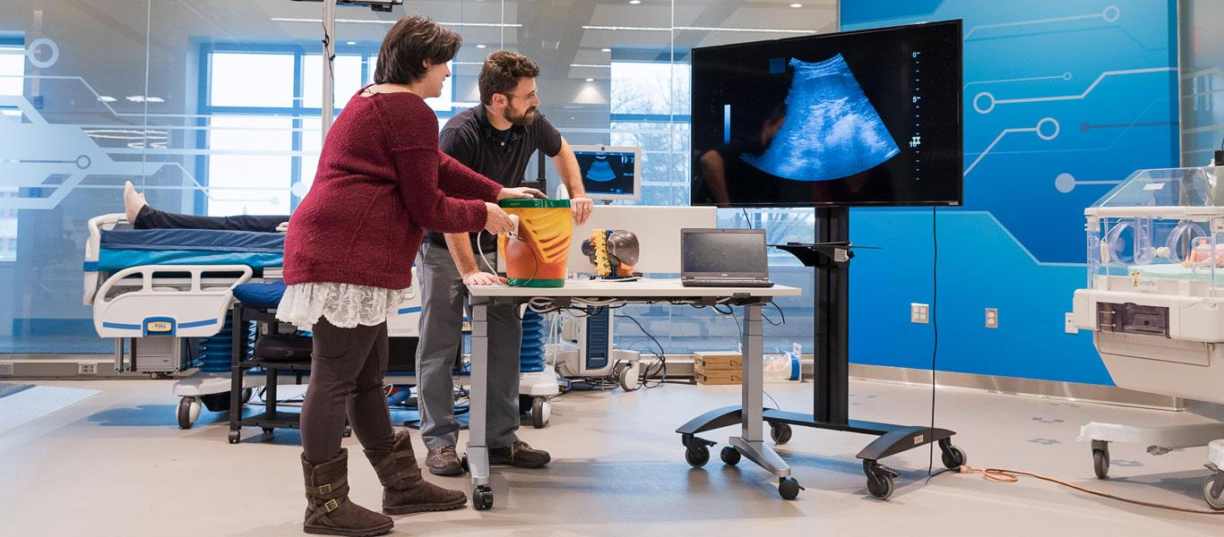

PROJECT

Bioelectronic Medicine Therapy for Targeted Neuromodulation
- HOME
- PROJECT
- Bioelectronic Medicine Therapy for Targeted Neuromodulation

Bioelectronic Medicine Therapy for Targeted Neuromodulation
The bioelectronic medicine team at GE Research are demonstrating potentially breakthrough non-invasive methods to regulate dysfunction in the body’s metabolic or inflammatory control systems using ultrasound.
Bioelectric medicine involves the study of new methods to treat chronic diseases such as Arthritis, IBS and diabetes by using devices to address dysfunctions in the nervous system that are believed to be key contributing factors to these diseases. In the past, bioelectronic medicine research typically relied on implanted devices to stimulate nerves for therapeutic outcome. The GE Research team is demonstrating the use of a non-invasive ultrasound technique to stimulate nerve features directly within target organs in a very precise manner.
The technique uses focused ultrasound to target the innervation points and areas of specific synaptic connection and physiological function. This approach employs the natural hierarchical structure and organization of the nervous system, enabling precision neuromodulation with a noninvasive stimulation technology. Ultrasound modulation of two completely different organs and distinct physiological pathways (the CAP in the spleen and metabolic sensory neurons/cells in the liver) was achieved with the same technology.
Continued work will be needed to further explore the potential of precision ultrasound neuromodulation. The GE Research team’s initial results suggest that further investment and research into the use of ultrasound for peripheral neuromodulation is justified and will require increased collaboration between ultrasound device engineers and neuroscientists.
In addition to the preclinical studies the GE Research bioelectronic medicine is working on, the team is also working with DARPA on a $2.9 MM project to study new treatments for diabetes using similar non-invasive stimulation techniques with ultrasound. The findings published by the GE/Feinstein team in the Nature Communications article related to regulating blood glucose represent the first steps toward making this a future reality.

Project Impact
The demonstration by the GE Research bioelectronic medicine team to noninvasively modulate neural signaling in peripheral organs has advanced the study of nerves and their effect on homeostasis and disease. The successful demonstration by the team that ultrasound stimulation within organs provides a new method for site-selective neuromodulation to regulate specific physiological functions means the treatment of certain chronic diseases, such as Arthritis, IBS, Multiple Sclerosis (MS) and diabetes, can be done through noninvasive measures.
- Our Expertise
Capabilities utilized for Bioelectronic Medicine Therapy for Targeted Neuromodulation project
- Ultrasound Imaging
Exploring the physics of ultrasound signal generation, propagation and detection for medical and industrial applications

• • Biosciences
Working from the molecular scale through human health and disease by building novel technology solutions for cell analysis and imaging applications

• • Microelectronics
Developing solutions from advanced imaging applications to embedded electronic systems and sensing systems for industrial and aeronautical applications

• • Machine Learning
Developing and scaling machine learning solutions for industrial applications to facilitate continuous learning, adaptation and improvement in dynamic operating environments

• • Computer Vision
Enhancing fundamental and applied research to mimic human visualization and interpretation

Project Team

We're ready to partner with you.
© 2020 General Electric

Footer
- PRIVACY
- TERMS OF USE
- USE OF COOKIES
- ACCESSIBILITY
- SITE MAP
We use cookies to personalize and enhance your experience on our site. Visit our Privacy Policy to learn more or manage your personal preferences in our Cookie Consent Tool. By using our site, you agree to our use of cookies.

